

FIAT Services

Medical Check Scheduling & Tracking
Business Blue Print

FIAT Services

0.2

Confidentiality/Disclaimer:

This document and all information contained within is the property of NorthgateArinso International. It is issued in confidence and must not be reproduced in whole or in part or used or given or communicated to any third party without the prior written consent of NorthgateArinso International.
This document does not form or constitute part of a contractual agreement, and its submission does not imply acceptance of any commercial terms.

Any statements and recommendations made or advice given shall not in any circumstances be deemed to constitute a warranty by NorthgateArinso International as to the accuracy of such statements, recommendations or advice. NorthgateArinso International shall not be liable for any loss, expense, damage or claim arising from the statements made or omitted to be made, or advice given or not given in this document.

Copyright NorthgateArinso International ©

Version Management:
Version | Date | Author | Comments
0.1 | 15.12.2012 | Boris Pijetlović | 1st Draft
0.2 | 16.12.2012 | Petrina Makakova | 2nd Draft
Document Distribution:
Name | Responsibility | Organization
Darko Čelebić | Supervisor | SDD ITG
Petrina Makakova | Project Manager | TMF
Liborio Pagano |  | FS

Contact Details:

Telephone: +381 11 2773964
Fax: +381 11 2781938
Mob:
Email: darko@sdditg.com

Confidentiality/Disclaimer:
This document and all information contained within is the property of NORTHGATEARINSO International (hereafter referred to as NORTHGATEARINSO). It is issued in confidence and must not be reproduced in whole or in part or used or given or communicated to any third party without the prior written consent of NORTHGATEARINSO.
This document does not form or constitute part of a contractual agreement, and its submission does not imply acceptance of any commercial terms.
Any statements and recommendations made or advice given shall not in any circumstances be deemed to constitute a warranty by NORTHGATEARINSO as to the accuracy of such statements, recommendations or advice. NORTHGATEARINSO shall not be liable for any loss, expense, damage or claim arising from the statements made or omitted to be made, or advice given or not given in this document.
Copyright NorthgateArinso International ©2006

Changing history
List of chapters modified:

Table of Contents
Changing history 4
Table of Contents 5
1 Introduction 6
2 SHORT DESCRIPTION 7
2.1 EMPLOYEES MANAGED IN THE TOOL 7
2.2 ASSIGNING RISKS TO A NEW / EXISTING EMPLOYEE 7
2.3 SCHEDULING A MEDICAL CHECK 8
2.4 PERFORMING A MEDICAL CHECK 9
2.5 REPORTING 9
2.6 MISCELLANEOUS 10
3 IMPACTS ON OTHER SYSTEMS 11
3.1 TIME MANAGEMENT (TM) 11
3.2 PERSONNEL ADMINISTRATION (PA) 11
3.3 SYNCHRONIZATION ENGINE BETWEEN PA AND TM 11
4 ROLES 12
5 Bussiness processes 13
5.1 MEDICAL DEPARTMENT STAFF 13
5.2 BC SUPERVISOR 14
5.3 WC 15
5.4 WC DR 16
5.5 FAS CEO / HEALTH & SAFETY DEPARTMENT 16

Introduction
This document analyzes the business processes and business requirements related to designing and implementing the new tool for scheduling and tracking the medical checks (the Tool).
This document has been prepared on the basis of information collected through a standard questionnaire and direct interviews with key users from Fiat Services doo Kragujevac (FS) in the period from late November to mid December 2012.
At present FAS does not use a tool for the same / similar purposes; consequently, a comparative and existing functionalities support analysis was not performed.
The fit between the business requirements and the functionalities of the Tool has been denoted with the following symbols:

N | Note
Χ | Alternative process
??? | Open Point
The legal entities within the scope of this document are:
- Fiat Automobili Srbija doo Kragujevac (FAS)
Other legal entities:
- Fiat Services doo Kragujevac (FS)
- Magneti Marelli doo Kragujevac (MM doo)
- Magneti Marelli Automotive doo Kragujevac (MM automotive).
are out of scope.

N | Introducing a new legal entity in the Tool will not be a change request if the business processes applicable to FAS are implemented to that new entity as well. If these business processes differ, the implementation of the Tool to that new legal entity will be subject to a new assessment (change request).
To avoid extra costs and make the most of existing tools and structures, this elaboration is made on the assumption that the Tool is functionally dependent on the PA and TM systems and cannot be a standalone system.

SHORT DESCRIPTION
Fiat Services Kragujevac needs a new tool for scheduling and tracking the medical checks for FAS employees (the Tool). The Tool will have certain data exchange with the PA and TM systems. The Tool will be used by the FAS Medical Department (MD), BC supervisors, FAS CEO, FAS Health & Safety Department, HR SSC, WCDR.

EMPLOYEES MANAGED IN THE TOOL
Only active employees will be managed in the Tool. These are:
- PA employee category compete: 1.“Regular employee with temporary contract”, 2.”Regular employee with permanent contract”, 3.”Employee with temporary and occasional contract”.
- PA employee status 1.”Active”
- PA: stringone is defined
Employee status complete.
The initial medical check of an employee in process of hiring is performed before the employee is officially employed. This initial medical check will not be supported by the Tool. i.e. employees in the process of hiring will not be visible in the Tool.
If needed, the results of the initial medical check can be entered after the hiring is completed.
MD will see employees who have left company (with termination date).

ASSIGNING RISKS TO A NEW / EXISTING EMPLOYEE
The medical checks to be performed will depend on the risks assigned to each employee. The risks will not be dependent on the employee’s position as defined in the PA, i.e. each employee will be assigned a specific set of risks which might vary from employee to employee holding the same position.

The initial assigning of risks to an employee will be made by the BC supervisors for BC and by the WCDR for WC (and other categories usually managed by WCDR in TM).
There is a default set of risks pre-assigned to each position. When assigning risks to a specific employee, the BC supervisors edit this list (add and delete risks) in accordance with the specifics of the employee’s job description.

SCHEDULING A MEDICAL CHECK
Each risk has the associated medical checks which should be performed at a pre-defined period (rotation; the initial rotation is calculated starting from the hiring date). The standard schedule of medical checks per employee will be calculated by the Tool on the basis of the pre-defined rotation for each risk. The schedule of medical checks will further be updated / confirmed by the MD.

The MD has to schedule / confirm the medical checks for the following month by the 21st day of the current month. The MD should be able to schedule medical checks during the shift of the employee only.

Once an appointment is scheduled, there will be shift additional check (on daily basis) and BC SUPERVISOR or WCDR will be alerted in the Tool, in case the employee’s shift has subsequently changed. It will be the responsibility of the MD to track whether a change of shift affects the employee’s next scheduled medical check and change the already scheduled medical checks.

The MD should have the following visibility:

- Employees for whom the medical checks have to be performed but are not yet scheduled;
- Employees who have had scheduled medical checks in the past but who did not have them (e.g. the employee did not come to the medical check);
- Employees for whom the medical checks have been scheduled and performed.

The MD will determine the time duration of the medical check, i.e. the medical checks will not have a pre-assigned duration.

The Tool should track the MD staff member who scheduled the medical check and the MD staff member who subsequently performed the medical check.

BC supervisors or WC DR can request medical checks on demand (out of regular rotation) by alerting the MD department. This will be done via the Tool. The MD will then schedule the requested medical checks.

After a medical check has been scheduled, a coupon will be created in a pre-defined format. The coupons for the BC medical checks will be printed out and distributed by the BC supervisors. BC supervisors will receive e-mails reminding them that there are coupons for printing and distribution.

WC will receive their coupons by e-mail (and WC DR will be in carbon copy).

PERFORMING A MEDICAL CHECK
Employees will check in / check out when exiting / entering their working areas for the scheduled medical checks.

The MD will validate the completion of each medical check in the Tool and on the coupon.

Upon performing the medical check, the MD will confirm whether the employee is within the norm for the respective medical check by noting any established temporary or permanent disabilities. In case the disability is temporary, the MD should be able to enter the duration of that disability in the Tool.
The MD will also have available a text box in which a free text pertaining to the particular exam can be entered (e.g. the blood pressure value that is measured during medical examination). This text box will not be subject to any further background processing, i.e. the tracking and keeping of medical data other than established permanent or temporary disabilities will not be supported by the Tool.
The libraries which the Tool will support are:
- Risks
- Work activities
- Rotations
- Vaccines
These libraries will not be synchronised with any other systems (PA or TM). A user authorised to do so will be able to maintain the libraries (entering, updating or deleting items).

BC supervisors and WCDR will have full access to all medical check results recorded in the Tool.

Some data will be collected during every medical check:
- weight
- height

N | Introducing some new attributes will be treated as fine tuning (no subject to a new assessment / change request).

There will be possible to track those data (historical view).

Special functionality will be designed for vaccine (scheduling and rotation of vaccine/ same bossiness logic as for medical examination).

Alerting system will be developed to notify MD that some period of disability of some employee is about to expire.

REPORTING
The Tool should allow the MD / BC supervisors to make various reports.
Standard set of report will be designed: listed data retrieved applying filter (according the UI) with export to XLS and/or CSV.

MISCELLANEOUS
BC supervisors / WC DR will be able to see only the members of their team, i.e. the visibility as compared to the current visibility in the TM is restricted. Visibility will be always the same as in TM.

The FAS CEO and FAS Health & Safety Department should have read only access to all data, in order to track activities, so a special read only role needs to be developed.

The tool has to have user management functionality: define new roles, assign users to roles.

IMPACTS ON OTHER SYSTEMS

TIME MANAGEMENT (TM)
There are no changes in TM. Only time schema data (shifts) will be retrieved from TM system. The transfer of shifts from the TM to the tool will be done in real time (during making appointment).

The TM System will receive no data flow from the Tool about the medical checks actually performed and their duration. When verifying the employee’s absences, the BC Supervisor / WC, should use code 0075 “Periodical Medical Check-up” to cover the clock-in / clock-out period in the TM System. This period should coincide with the period noted on the MD certified coupon which the employee will return to the BC Supervisor.

PERSONNEL ADMINISTRATION (PA)
There are no changes in the PA. The PA data that the new tool will be using will be included in the regular PA – TM synchronization flow.

N | If during the design process there is a new requirement for adding employee data which is not currently present in the TM but exists in PA and which is not subject to any additional processing by the PA, this will be treated as a fine tuning and will not be subject to a change request.

SYNCHRONIZATION ENGINE BETWEEN PA AND TM
There are some new attributes:
- employee address

ROLES
This chapter describes the roles (specific users will have one or more roles), which give user desired functionalities and performing specified business activities.

Roles should be:

Role | System access
Medical department staff | DIRECT ACCESS
BC SUPERVISOR | DIRECT ACCESS
FAS CEO | DIRECT ACCESS
WC | NO DIRECT ACCESS (email)
WCDR | DIRECT ACCESS

Following diagram depicture required roles:
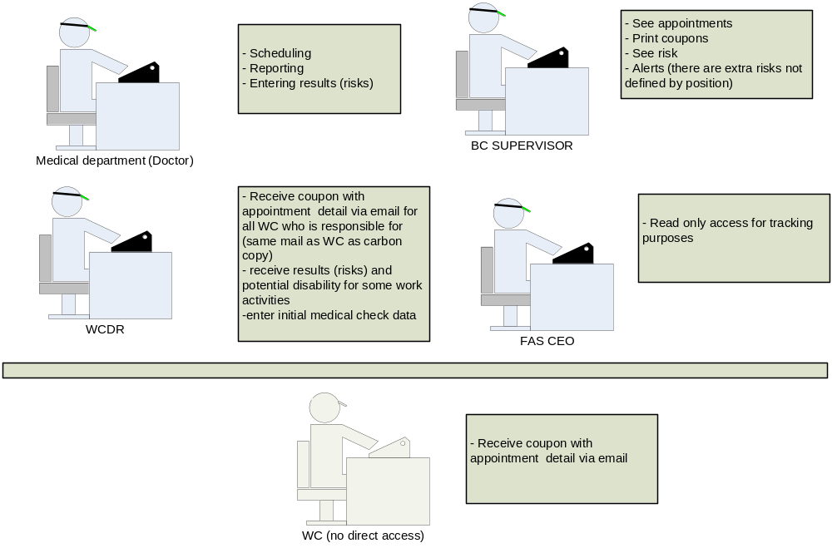

Bussiness processes
This chapter describes business processes in system performed by separate roles.

MEDICAL DEPARTMENT STAFF
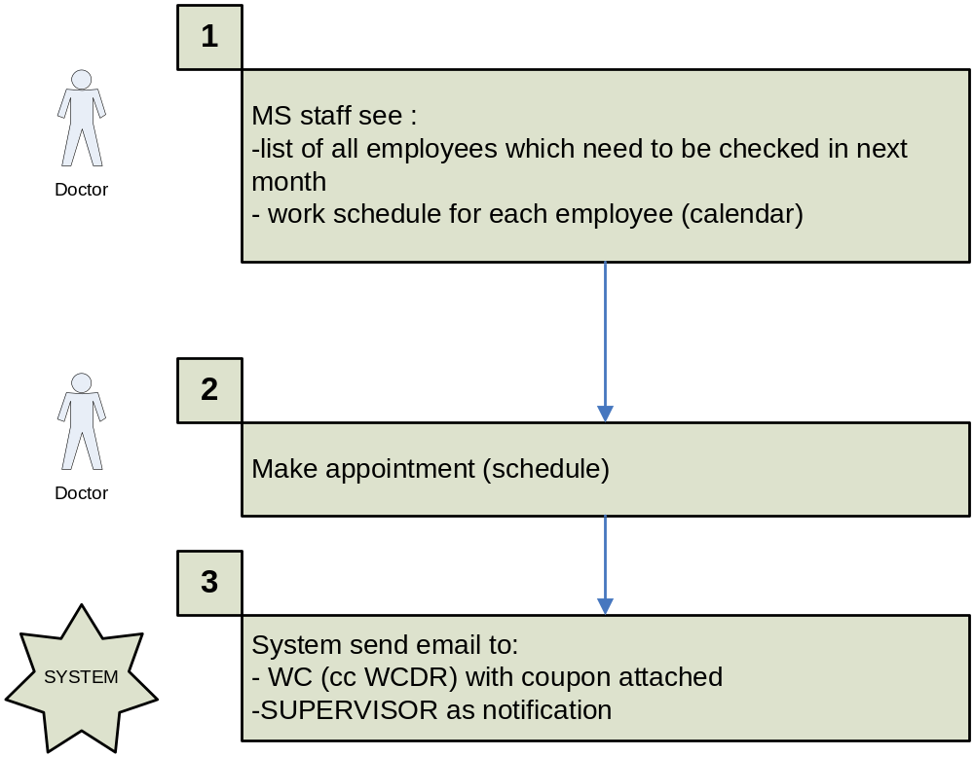

BC SUPERVISOR

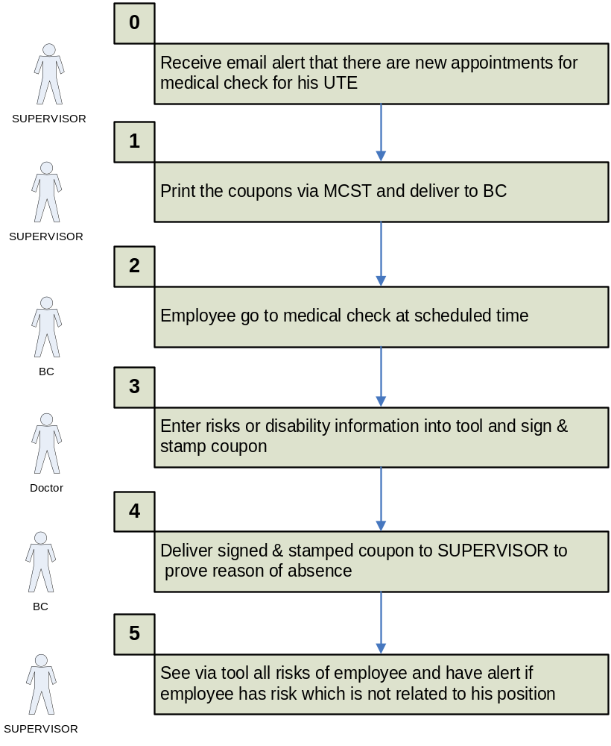

WC
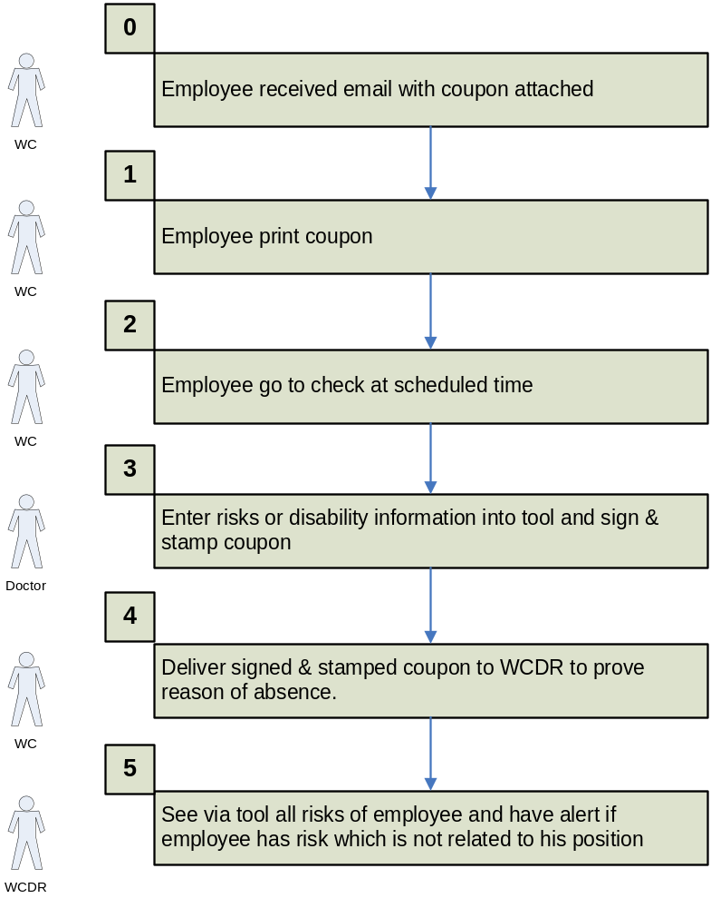

WC DR
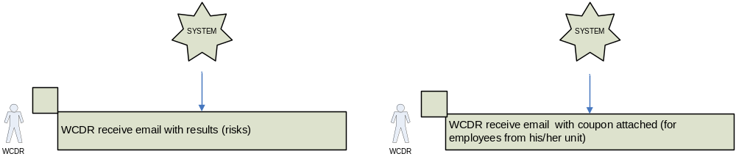

FAS CEO / HEALTH & SAFETY DEPARTMENT
Read only access to all system functionalities.

